Tutorial week 4 – SQL Catch up!
… note that these tasks are based on scott tables taken from the workbook you were told to work on between last week’s session and this!

Topics covered are:
- Sub queries
- Group by/Having
- Self join
- Outer join
- Views

Note: These icons are used throughout this tutorial:

 An example showing how to do something

 A task for you to complete

 Good to know!

An example and a task for you to complete

1. Using Sub queries
A sub query answers, multiple-part questions. For example, to determine who works in Taylor's department, you can first use a sub query to determine the department in which Taylor works. You can then answer the original question with the parent SELECT statement. A sub query in the FROM clause of a SELECT statement is also called an inline view. A sub query in the WHERE clause of a SELECT statement is often called a nested sub query.
List all employees who have a salary higher than average salary. First of all you need to know what the AVG salary is. The statement SELECT AVG(sal) FROM emp will calculate this for you and produce a result of 2073.2142857
This result can be rounded using the ROUND function,
Q1 . SELECT ROUND (AVG(sal)) FROM emp
This will produce a result of 2073. You can then use this result to produce a list of all employees who have a salary higher than the AVG salary.
Q2. SELECT deptno, ename, sal FROM emp WHERE sal > 2073

DEPTNO | ENAME | SAL
20 | JONES | 2975
30 | BLAKE | 2850
10 | CLARK | 2450
20 | SCOTT | 3000
10 | KING | 5000
20 | FORD | 3000

To sort the output use ORDER BY.

In the previous case you had to write two SQL statements to produce the output. What you could have done originally is produce a subquery.

See the example:
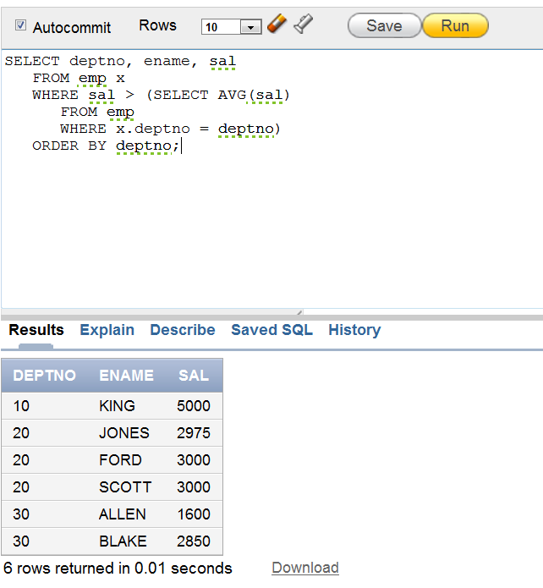

To Read more about this topic, please go to MyBeckett > week 3 in class materials folder, document called ‘week 3 Reading for tutorial – SQL Intermediate and Advanced’.

Exercise 1
List all the departments where there are no employees (using a sub-query). Run and save your query as subquery1.sql

NOT IN operator is used to link sub and main query.

To help you with the task, the syntax for the query is given below:

SELECT col1, col2
FROM table1
WHERE col1 NOT IN
(SELECT col1
FROM table2);

Exercise 2
Find the most recently hired employees in each department.
You will have to write a sub-query here. GROUP BY will be explained later.

Run and Save your query as subquery2.sql

Syntax

SELECT columns...
FROM table
WHERE (col1, col2) IN
(SELECTmax(col1), col2
FROM table
Group by col);

The following should be output:

DEPTNO | ENAME | HIREDATE
20 | ADAMS | 05/23/1987
30 | JAMES | 12/03/1981
10 | MILLER | 01/23/1982

Exercise 3
Show the following details for any employee who earns a salary greater than the average for their department:

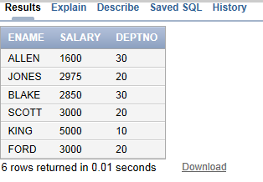

Save your query as subquery3.sql

Exercise 4
Find the employee(s) who earn the highest salary in each job type. Run and save your query as subquery4.sql

JOB | ENAME | SAL
SALESMAN | ALLEN | 1600
MANAGER | JONES | 2975
ANALYST | SCOTT | 3000
PRESIDENT | KING | 5000
ANALYST | FORD | 3000
CLERK | MILLER | 1300

Exercise 5
Find the employees who earn the minimum salary for their job. Display the result in ascending order of salary.

Exercise 6
Your task is to write a statement to find out who works for the Sales Department, but is not a SALESMAN?

2. Group By / Having
Aggregate functions (MAX, AVG, MIN) return a single result row based on groups of rows, rather than on single rows. They are commonly used with the GROUP BY clause in a SELECT statement, where Oracle Database divides the rows of a queried table or view into groups.
You use aggregate functions in the HAVING clause to eliminate groups from the output based on the results of the aggregate functions, rather than on the values of the individual rows of the queried table or view.
Exercise 7
List the minimum and maximum salary for each job type where the output should look like this:

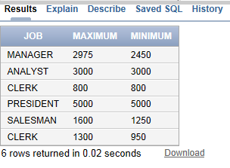
Save your query as groupby.sql

Syntax for retrieving data from a table

SELECT column, group function (column)
FROM tablename
GROUP BY column/expression;
Exercise 8
Find all departments which have more than 3 employees. To help you with this task, you are given a solution to the newest/hardest part. Run and Save your query as groupbyhaving.sql

SELECT col, count(*)
FROM table
GROUP BY col
having count(*) > 3;

Exercise 9
List lowest paid employees working for each manager. Exclude any groups where the salary is less than 1000. Sort the output by salary. Use Group By and Having here.

Your output should look like this:
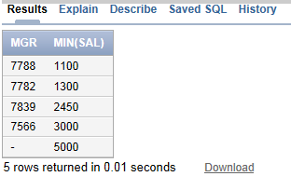
Save your query as groupbyhaving2.sql

To Read more about this topic, please go to VLE > week 3 in class materials folder, document called ‘week 2 Reading for tutorial – SQL Intermediate and Advanced’.

3. Using Self Joins

Example: The following query uses a self-join to return the name of each employee along with the name of the employee's manager.

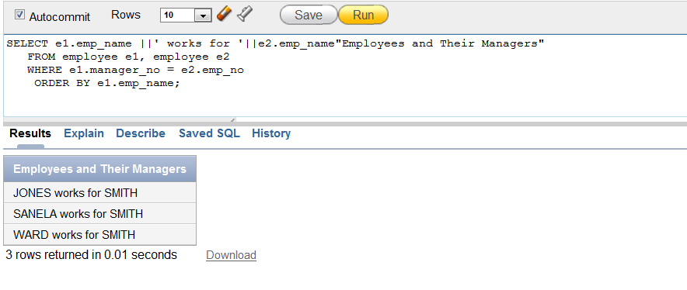The join condition for this query uses the aliases e1 and e2 for the sample table employees: e1.manager_no = e2.emp_no

To Read more about this topic, please go to VLE > week 3 in class materials folder, document called ‘week 2 Reading for tutorial – SQL Intermediate and Advanced’.

Exercise 10

List all employees by name and number along with their manager's name and number. This is a self-join statement. This statement is most often used on a table with a recursive relationship, as in this case study – emp table. Run and Save the code as selfjoin.sql

Your output should look like this.
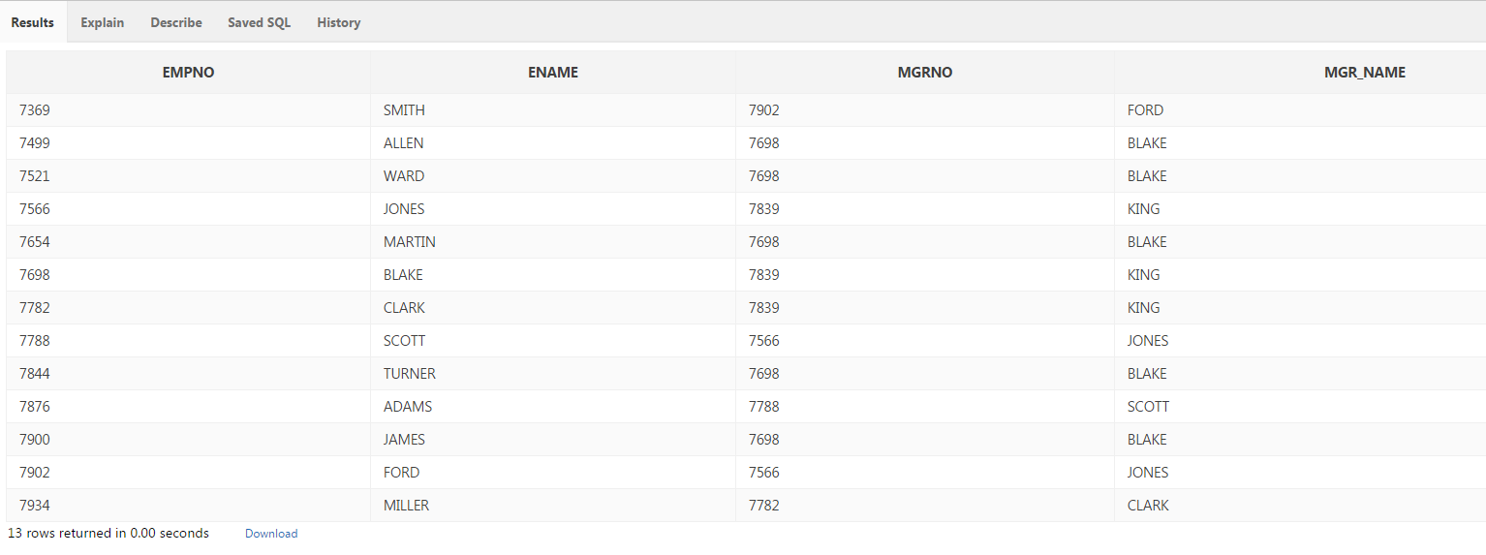

4. Outer Joins
Exercise 11
Write a statement to display employee KING who has no manager. You will use the (+) outer join operator for this statement. Save the query as outerjoin1.

You have been given part of the query:

SELECT emps.empno, emps.ename, mgrs.empno mgrno, mgrs.ename, mgr_name
FROM emp emps, emp mgrs
WHERE emps.mgr = mgrs.empno;
Exercise 12
Display the department that has no employees. Run and Save the query as outerjoin2.sql
Exercise 13
Display those who manage employees in either department 10 or 20. Order by manager number. Use a UNION join here. Run and Save the query as union1.sql

The syntax is:
SELECT col
FROM table
WHERE col = ‘value’
UNION
SELECT col
FROM table
WHERE col = ‘value’

Exercise 14
Find any jobs that were filled in the first half of 1983 and were also filled during the same period 1984. Save your query as union2.sql

Exercise 15

Find all employees who joined the company before their manager. Save your query.

To Read more about this topic, please go to VLE > week 3 in class materials folder, document called ‘week 3 Reading for tutorial – SQL Intermediate and Advanced’.

5. Views
The CREATE VIEW statement creates a view of the tables specified in the Select Query clause. A view is a logical table that is based on one or more detail tables. The view itself contains no data. It is sometimes called a non-materialized view to distinguish it from a materialized view, which does contain data that has already been calculated from detail tables.
Syntax:
DROP VIEW ViewName;
CREATE VIEW ViewName AS SelectQuery
CREATE OR REPLACE VIEW v_emp
AS
SELECT EMPNO, ename,sal,comm, e.deptno, dname
FROM emp e, dept d
WHERE e.deptno = d.deptno;

To view data in the view, you can write an SQL statement:

SELECT * FROM v_emp;

EMPNO | ENAME | SAL | COMM | DEPTNO | DNAME
---------- | ---------- | ---------- | ---------- | ---------- | ----------
7369 | SMITH |  |  | 20 | RESEARCH
7499 | ALLEN | 1600 | 300 | 30 | SALES
7521 | WARD | 1250 | 500 | 30 | SALES
7566 | JONES | 2975 |  | 20 | RESEARCH
7654 | MARTIN | 1250 | 1400 | 30 | SALES
7698 | BLAKE | 2850 |  | 30 | SALES
7782 | CLARK | 2450 |  | 10 | ACCOUNTING
7788 | SCOTT | 3000 |  | 20 | RESEARCH
7839 | KING | 5000 |  | 10 | ACCOUNTING
7844 | TURNER | 1500 | 0 | 30 | SALES
7876 | ADAMS | 1100 |  | 20 | RESEARCH
7900 | JAMES | 950 |  | 30 | SALES
7902 | FORD | 3000 |  | 20 | RESEARCH
7934 | MILLER | 1300 |  | 10 | ACCOUNTING

Exercise 16

View: Create a view to hold non-sensitive data on all employees in Dallas. Use the lecture slides from week 3 to see how to create a view. Once you have created your view, select data for the employees who are managed by manager 7566.

DROP VIEW ViewName;

CREATE VIEW ViewName
AS Select col2, col2, col3
From table1, table 2
Where join ... etc

To Read more about this topic, please go to VLE > week 3 in class materials folder, document called ‘week 2 Reading for tutorial – SQL Intermediate and Advanced’.

